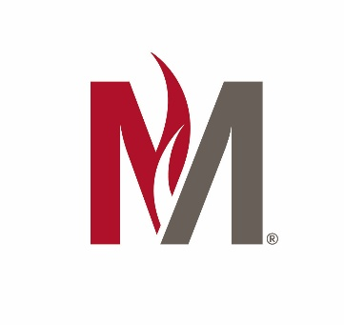

Accessibility Statement
Minnesota State University Moorhead (MSUM) is committed to providing equitable access to learning opportunities for all students and strives to make courses inclusive and accessible in accordance with sections 504 of the 1973 Rehabilitation Act and the Americans with Disabilities Act (ADA). The University will make reasonable accommodations for students with reported disabilities/conditions or barriers.
Accessibility Resources (AR) is available to facilitate a range of academic support services and accommodations for students who identify a barrier which hinders their academic experience. If you have a disability/condition or barrier, you can request assistance by contacting AR at accessibility@mnstate.edu (email), 218-477-2167 (voice), or 218-477-4366 (fax). Once eligibility has been determined, students register with AR every semester to activate their approved accommodations. Although a student may request an accommodation at any time, it is best to initiate the application process at least four weeks before a student wishes to receive an accommodation.
Students may begin the accommodation process by submitting a Request for Accommodations form or contact Accessibility Resources.
The Director of Accessibility Resources, Chuck Eade, serves as MSUM’s ADA Coordinator for students. He can be reached at Charles.Eade@mnstate.edu. Additional information is available on the AR website: https://www.mnstate.edu/accessibility.

