LITERACY RESOURCES FOR OUR PERUVIAN FRIENDS
Resource for Parents and Families
Aprender y Leer: La Lectura Es Lo Primero: Como Ayudar A Su Hijo A Aprender A Leer: Una Guia Para Padres De Familia: Del Preescolar Al Tercer Grado
Aprender a leer y a escribir en inglés es una de las destrezas más importantes que su niño va a adquirir en la escuela.
You can download the pdf of this book free at the website below. You may also order hard copies of it free.
https://www.nichd.nih.gov/publications/list/collection?g=8&col=18&cat=all

Phonemic Awareness
Yopp, H., & Yopp, R. (2009). Phonological Awareness Is Child's Play! YC Young Children, 64(1), 12-21. Retrieved from http://www.jstor.org/stable/42731019

Yopp, H.K.., & Stapleton. (2008). Conciencia fonemica en espanol (Phonemic awareness in Spanish). The Reading Teacher, 61(5), 374-82.

https://www.amazon.com/Early-Childhood-Phonemic-Awareness-Activities/dp/142580697X/ref=sr_1_2?keywords=early+childhood+phonemic+awareness+activities&qid=1550715361&s=gateway&sr=8-2
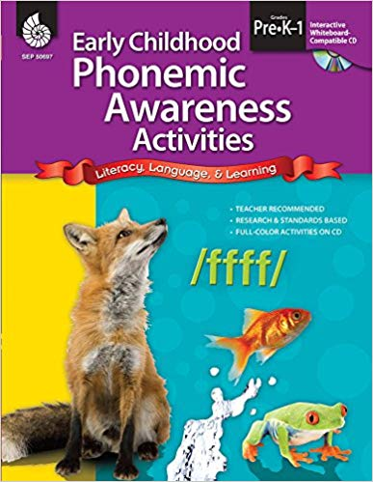
Fluency
Timothy Rasinski, Ph.D., is a widely-known professor, author, and presenter on the topic of fluency. His website includes a variety of free resources. http://www.timrasinski.com/index.html
Florida Center for Reading Research http://www.fcrr.org/resources/
Building Fluent Readers: http://www.teachingwithamountainview.com/2013/04/top-10-tips-for-building-fluent-readers.html
Early Literacy Strategy Poster
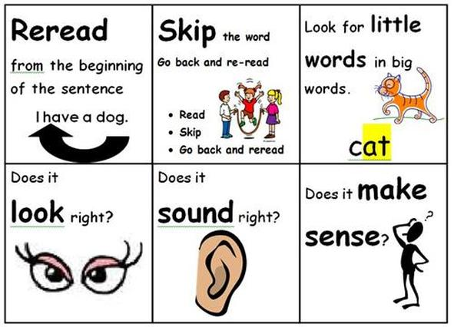
http://mmekatie.weebly.com/literacy.html

Running Records
Marie Clay is the founder of Reading Recovery, an intensive 20-week intervention for your struggling readers. Although book (see link below) doesn’t address Reading Recovery, it does provide the basics of using running records as a basis for assessment of student reading.

https://www.amazon.com/Running-Records-Classroom-Teachers-Marie/dp/1407159976/ref=asc_df_1407159976/?tag=hyprod-20&linkCode=df0&hvadid=317170508585&hvpos=1o1&hvnetw=g&hvrand=14314504566650801358&hvpone=&hvptwo=&hvqmt=&hvdev=c&hvdvcmdl=&hvlocint=&hvlocphy=9020213&hvtargid=aud-643330155750:pla-569310369550&psc=1

Information on running records: http://scholastic.ca/education/movingupwithliteracyplace/pdfs/grade4/runningrecords.pdf

