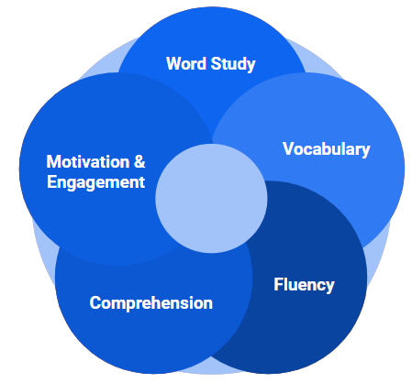
Elements of Effective
Adolescent Literacy Programs
Word Study:
- Tier 2 and Tier 3 interventions for students who have not mastered decoding strategies
- Explicit instruction for irregular words and root words/prefixes/suffixes
Vocabulary:
- Implicit instruction through readings and class discussions
- Explicit instruction through mini-lessons, graphic organizers, and sketches
Fluency:
- Teacher read-aloud
- Pair/Small-group reading and Readers Theater
Comprehension:
- Explicit instruction of comprehension strategies
- Peer discussions
- Varied reading opportunities
Motivation:
- Student choice
- Text accessibility
- Positive learning environment and teacher/student relationships
Engagement:
- Peer interactions
- Authentic reading opportunities
Kathrina O’Connell: oconnellka@mnstate.edu or koconnell@lpa.k12.mn.us

